

**Name: Awaab Khan (FA20-BSE-092)**

**Submitted to: Ms. Samra Siddique**

**Project: “Pain & Gain”**

**“Vision Document”**

1. **Introduction**
   1. **Purpose of the vision document:**

**Some of the reason of creating this website**

* Scheduling online fitness classes
* Selling diet and gym products
* Manage client coaching by giving personal training
  1. **Product overview**

We are planning on developing a fitness management system for the ease and comfort of the users who want to join gym who don’t know what should be their complete diet and training schedule. For each and every person falling in different category of weight, height it will be useful for them to resurrect.

1. **User Description**

**2.1 User/Market Demographics:**

The target user of our website are those people who don’t have a lot of time to go to the gym and just want to perform daily routine excersice because of shortage of time and we will also provide ecommerce module so that they can buy the product as well. Because of these users we are creating this website which will benefit the user and us as well

**2.2 User Profile:**

|  |  |
| --- | --- |
| Admin | Manages supplier and customer. |
| Customer | Buy product, Add to card, Gym registration, train from professional trainer. |
| Supplier | Supplier send his profile to admin and then after selection set his profile and update products. |
| Personal Trainer | He will have direct interaction with the user who wants to be train and will have his own portal. |

**2.3 User Environment:**

**Designing Tools:**

* Draw.io
* Microsoft Visio

**Frontend:**

* React JS
* Tailwind CSS

**Backend:**

* Rest API’s
* Node JS
* Express JS

**Architecture:**

* Model-view-controller (MVC)

**Database:**

* Mongo DB
* Firebase

**Browser:**

* Google chrome
* Firefox

1. **Product Overview**

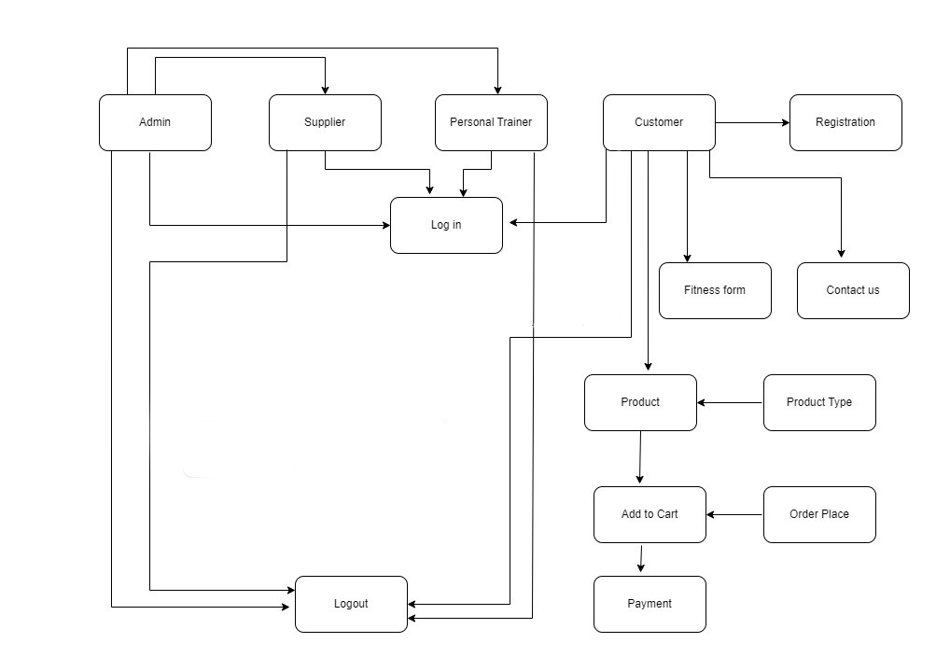**3.1 Product Perspective:**

**3.2 Product Position Statement:**

|  |  |
| --- | --- |
| **For** | Individual looking to maintain their body and buy gym accessories. |
| **Who** | Our product targets the customer and supplier (the person who need a platform to sell his product) and personal trainer (a person who can earn money by training immature customer who wants to be trained)  Benefits:  Our website provide a platform for the suppliers and personal trainer who can earn money easily |
| **The(Product name)** | Pain and Gain(fitness and ecommerce website) |
| **That** | Benefits:  Customer: can easily perform day to day routine excersice without any complexity and can also avail the opportunity to be train by a professional.  Supplier: provides a platform for the supplier to sell his products easily and earn money.  Personal trainer: provides a platform for personal trainer to train immature customer routine excersice and get benefit from that |
| **Our Product** | Our website provides an online fitness service as well as a personal trainer and also provide an opportunity to buy gym products |

**3.3 Summary of Capability:**

|  |  |
| --- | --- |
| **Customer Benefit** | **Supporting Features** |
| Customer can easily search product by writing the first letter of the product name easily | Search Product |
| The customer can easily select a product and add this product to his cart in order to buy the product | Add to cart |

**3.4 Assumptions and Dependencies:**

* In using the website, we assume that the user is literate and can type in order to use the website and register
* Now we assume that the user has provided the right information while registering
* It is also assumed that the network on the user phone will be available.
* It is also assumed that the information provided by the user in the payment form will be valid and complete.
* It is assumed that the supplier has access to manage the products

**3.5 Cost and Pricing:**

The discounts in the ecommerce module(products) is available for the registered user but it’s ratio is greater for the users who are using personal trainee and paying for the personal trainer as compared to the normal registered users as the simple trainee module is free of cost.

For example:

There are 30% flat discounts for the personal trainee users

There are 15% discounts for the normal register users.

1. **Feature Attributes**
2. **Search product**

|  |  |
| --- | --- |
| Status | Approved |
| Priority | Important |
| Effort | Medium |
| Risk | Low |
| Stability | High |
| Target release | Version 1.0 |
| Assign to | Customer |
| Reason | To select the product easily |

1. **Contact us**

|  |  |
| --- | --- |
| Status | Approved |
| Priority | Important |
| Effort | Medium |
| Risk | Low |
| Stability | High |
| Target release | Version 1.0 |
| Assign to | Customer |
| Reason | To enter their query |

1. **Product Features**
   1. **Feature 1:**

Customer can search product

* 1. **Feature 2:**

Customer can add product to their cart

Customer can remove product from their cart